**Important Links**

**IS480 -** [**http://blue.smu.edu.sg/IS480/2018-2019/index.html**](http://blue.smu.edu.sg/IS480/2018-2019/index.html)

**IS480 Wiki -** [**https://wiki.smu.edu.sg/is480/Main_Page**](https://wiki.smu.edu.sg/is480/Main_Page)

**Important Dates**

* [Proposal](http://blue.smu.edu.sg/IS480/2018-2019/Grading.html?tab=1#TabbedPanels1) 20 Jun (2 months before)
* [Acceptance](http://blue.smu.edu.sg/IS480/2018-2019/Grading.html?tab=2#TabbedPanels1) 15-21 Aug (-1 & 1st week)
* Registration, Class and Awards 23 Aug 7-9pm at Auditorium. (1st week)
* [Midterm](http://blue.smu.edu.sg/IS480/2018-2019/Grading.html?tab=3#TabbedPanels1) 4-10 Oct (week 7 & 8)
* [Poster](http://blue.smu.edu.sg/IS480/2018-2019/Grading.html?tab=4#TabbedPanels1) 29 Oct (week 11)
* [Final](http://blue.smu.edu.sg/IS480/2018-2019/Grading.html?tab=5#TabbedPanels1) 19-27 Nov (week 14-15)

**Team Name: Tempest**

**Roles**

Gwee Qiao Lin Kimberly - Project Manager/ Deputy Quality Assurance  
  
Wong Jia'an - Lead Quality Assurance/ Deputy Project Manager  
  
Tay Wei Xuan - Lead Back End/ Deputy Business Analyst  
Yong Wei Jie Jacky - System Architect/ Deputy Back End   
  
Josh Gautam Dorai - Lead Front End/ Deputy System Architect  
Ng Chantalle - Business Analyst/ Deputy Front End

**Additional Info**

1. The number of outlets under Monsoon Group to be placed in the website. (Total 9 outlet with 5 different branding)

2. The name and job title of the stylists in each outlet (this is so that clients will be able to make appointments online) - i will send you in the next email with namelist & title)

3. The peak period of the salons (5-8pm on weekdays, Sat & Sun)

4. What is the system used now for appointment booking? , - we are still using telephone call as our priority, alternatively, can use our M-style Mobile Apps to make a booking.

26th November is good for presentation

Can i know what format you prefer for logo?



**IS480 Project Proposal**

**Monsoon Group Website**

**Tempest**

**Version 1.0**

**27 February 2018**

|  |  |  |
| --- | --- | --- |
| **Member** | **Role** | **Contact** |
| Gwee Qiao Lin Kimberly | Project Manager  Deputy Quality Assurance | ql.gwee.2015@sis.smu.edu.sg |
| Wong Jia'an | Lead Quality Assurance  Deputy Project Manager | jiaan.wong.2015@sis.smu.edu.sg |
| Tay Wei Xuan | Lead Back End Developer  Deputy Business Analyst | weixuan.tay.2015@sis.smu.edu.sg |
| Yong Wei Jie Jacky | System Architect  Deputy Back End Developer | jacky.yong.2015@sis.smu.edu.sg |
| Josh Gautam Dorai | Lead Front End Developer  Deputy System Architect | joshdorai.2015@sis.smu.edu.sg |
| Ng Chantalle | Business Analyst  Deputy Front End Developer | chantalleng.2015@smu.edu.sg |

**Faculty Supervisor:**

* Name[2]

**Sponsor :**

Monsoon Hair Group

* Addy Lee - Founder and CEO (97858463)
* Jason - Marketing Director (93882842)

**PROJECT OVERVIEW**

**1.1 Project Description & Motivation:**

Although Monsoon Hair group has been around for over 20 years, their business has yet to employ successful digital solutions to improve the efficiency and the business of their day-to-day operations. A mobile application was created in the past, however is unusable now due to bugs. As of now, receptionists manually take note of clients calling in to make their appointments and again, manually coordinating client bookings with the stylist schedules. The manual execution of this task also opens up room for errors such as double booking a stylist. Monsoon currently does not keep track of their client’s prior treatments and expenditure at their hair salon and are losing out on opportunities to push for returning client-specific marketing strategies and for improving their client relationship management. Monsoon also has its own range of hair care products that are only being promoted in store and on their social media platforms but have yet to achieve full sales potential as these products are only accessible in store and not online. Monsoon is also losing out on ways to engage its existing and potential customers as the spread of influence of their business is mainly through word of mouth since they do not have an online presence. This project will include functionalities that have been requested and agreed upon discussions with Monsoon. After deploying our web solution, we aim to have Monsoon’s clients make 100 appointments made with the stylists through the system. Our web solution aims to address these issues through the various application modules we have expressed in the later part of our project scope **(refer to 1.4 Deliverables and 1.5 Scope)**

**1.2 Stakeholders:**

|  |  |
| --- | --- |
| Sponsor | The team initiated the project with Monsoon Hair Group. One of our team members has been a long-time client with their salon and knows the founder personally.  *Contact Person’s Role: Addy Lee - Founder and CEO, Jason - Marketing Director* |
| User | There are 2 groups of users for our system:  (1) clients of the salon. As the main user of the website, they will use the site to book appointments, purchase products from the e-store, etc.  (2) Admin staff of the salon. As the secondary user of the website, they will update the site as necessary for the client’s viewing, and internal viewing of client history etc. |

**1.3 Deliverables:**

To address the business issues and needs, we will be developing a website with a series of functionalities helpful for a salon (refer to **1.4 Scope** for scope and full list of functionalities), such as appointment booking system, client information dashboard and e-store functionalities. With our web solution deliverables, we aim to help Monsoon streamline their business operations and to help them create an online presence that will not only promote brand visibility but also increase engagement between the brand and its clients.

**1.4 Scope:**

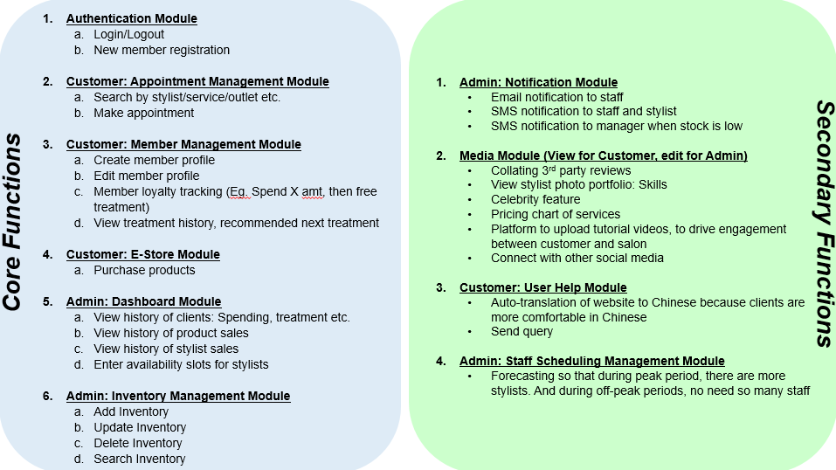

**PROJECT PLAN**

**1 iteration is 2 weeks, 9 iterations altogether**

## **PROJECT TIMELINE:**

Week 0: 29th April to 6th May

*CHANGE UPDATES ON MONDAY*

Meeting 1 (Wed):

* IDP Prototyping
* Split according to functions and present
* Metrics document
* Create repository
* Create AWS accounts

Meeting 2 (Sat):

* Diagrams
* Class diagrams
* ER diagrams
* Database creation

Week 1: 6th May to 12th May [AUTHENTICATION MODULE]

*CHANGE UPDATES ON MONDAY*

Meeting 1 (Wed):

* Update changes from week 0

Meeting 2 (Sat):

* Coders code the authentication
* Non-coders work on test cases

Week 2: 13th May to 19th May [APPOINTMENT MANAGEMENT MODULE]

*CHANGE UPDATES ON MONDAY*

Meeting 1 (Wed):

* Update changes from week 1

Meeting 2 (Sat):

* Make Appointments
* Search by stylists

Week 3:

Week 4:

Week 5: [E-STORE MODULE]

Week 6: [E-PAYMENT MODULE]

* Credit card and Paypal

Week 7:

Week 8:

Week 9:

Week 10:

Week 11:

Week 12:

Week 13:

Week 14:

Week 15:

Week 16:

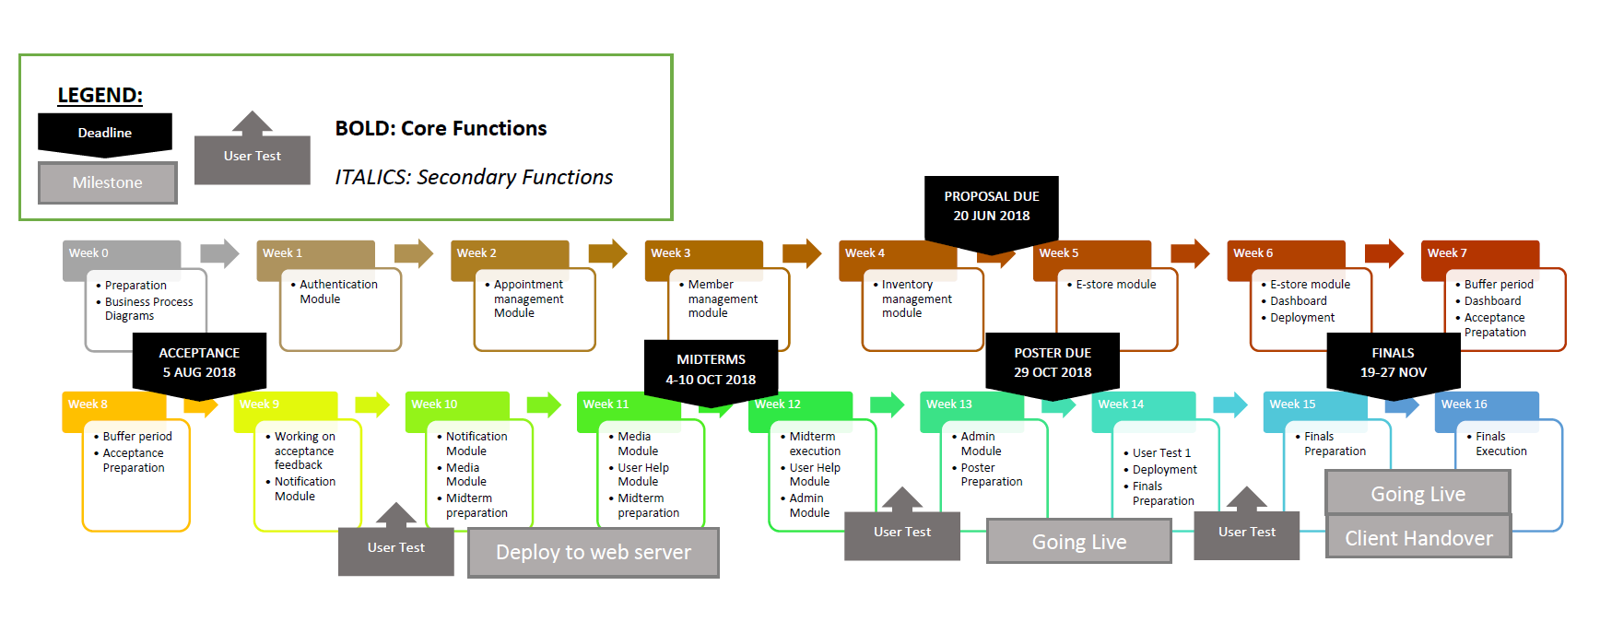

## **RISKS & MITIGATION:**

|  |  |
| --- | --- |
| **RISKS** | **MITIGATION** |
| Delay of Functions | Plan out the schedule with critical path  Ensure the team is reminded of the functions that needs to be completed  Add in more days to work on the function before the deadline of that particular functions  Constantly review and re-estimate the time required for each task in project schedule. |
| Response from main contact maybe slow | Come up with a list of questions before working on the project/function and sent to the contact to review.  Take note of the buffer time between sending and replying to our queries (uncertain when the client will reply).  Try to use all forms of communications if it’s it important (Email,SMS) |
| Integration of functions/codes | Ensure each function is done before integrating  Schedule a day for integration  Communicate with the front-end and back-end developer when integrating.  Test functions after integrating to make sure everything runs smoothly |

## 

## **RESOURCE & REFERENCES:**

|  |  |  |  |  |  |
| --- | --- | --- | --- | --- | --- |
| **Database** | **Frameworks** | **Server** | **Version Control** | **Development** | **Project Management** |
| MySQL phpMyAdmin | Bootstrap AngularJS | Amazon Web Service Heroku Apache Tomcat | Github | Netbeans | Slack |

|  |  |  |
| --- | --- | --- |
| **Programming Languages** | | **Communication** |
| HTML CSS Jquery JavaScript | PHP Java SQL | Telegram  Whatsapp |